CERTIFICATE
This is certify that Parth Pal in class XII has Satisfactorily compiled project with the tittle REPORT CARD MANAGEMENT SYSTEM under the guidance of Mr. Madhav Singhal, (Informatics Practices) during the academic year 2025-2026 in partial fulfilment of “Informatics Practices” Practical Examination of Central Board Of Secondary Education(CBSE)

Internal Examiner: External Examiner:

Acknowledgement
I am extremely grateful to Mr. Madhav Singhal for his invaluable guidance, constant support, and encouragement throughout the course of this project. His advice and constructive feedback helped us complete this project successfully.
I would also like to thank JBG International School for providing the necessary facilities, resources, and environment to work on this project efficiently.
Special thanks to my families and friends for their motivation and support, which helped me stay focused and complete this project on time.
a

Preface
The purpose of this project, “Student Report Card Management System Using Python and SQLite”, is to automate the process of maintaining student records, entering marks, generating report cards, and exporting them to PDF format.
This system is designed to be user-friendly, efficient, and accurate, helping schools save time and minimize manual errors in record-keeping.
The project is developed using Python for programming and SQLite as the database, and it incorporates features like:
- Adding student records
- Updating and validating marks
- Viewing individual and all student reports
- Exporting report cards as professional PDF files

S.No. | Topic/Section | Page No.
1 | Certificate | 1
2 | Acknowledgement | 2
3 | Preface | 3
4 | Table of Contents | 4
5 | Introduction | 5
6 | Objective of the Project | 6
7 | Tools and Technologies Used | 7
8 | System Design/ Flowchart | 8
9 | Code Explanation/ Implementation/ Output Screen/ Sample Reports | 9-16
10 | Conclusion and future Scope | 17
11 | Code | 18-24
12 | References | 25
INDEX

Introduction
In today’s educational environment, managing student records and generating report cards manually can be time-consuming and error-prone. The “Student Report Card Management System Using Python and SQLite” is designed to automate this process efficiently.
This system allows schools to:
- Maintain detailed student information including roll number, name, class, and marks.
- Enter and update marks for multiple subjects easily.
- Generate report cards automatically and export them as PDF files with professional formatting.
- View individual student performance as well as all student records in a convenient way.
By using Python for development and SQLite as the database, this system ensures reliability, accuracy, and ease of use. Additionally, the generated PDFs can include the school logo, borders, and a professional layout, giving a polished look to each report card.
This project aims to save time, reduce manual errors, and improve record management in educational institutions.
Objectives
The main objectives of the “Student Report Card Management System Using Python and SQLite” are:
- Automate Student Records: To maintain and manage student information efficiently, reducing reliance on manual record-keeping.
- Accurate Marks Entry: To allow teachers to enter and update marks for various subjects with validation to minimize errors.
- Generate Report Cards: To automatically create professional report cards in PDF format with school logo, borders, and a clear performance summary.
- Performance Analysis: To calculate total marks, percentage, and grades for each student and provide a quick overview of their academic performance.
- View and Search Records: To enable easy viewing of individual student reports as well as the entire student list.
- User-Friendly System: To design an interface that is simple and convenient for teachers and administrative staff to use.
Goal: To improve efficiency, accuracy, and professionalism in academic record management for schools.

Tools and Technologies Used
The Student Report Card Management System is developed using the following tools and technologies:
- Python:
  - The primary programming language used for developing the project.
  - Handles database operations, user interaction, calculations, and PDF generation.
- SQLite:
  - Lightweight relational database to store student information and marks.
  - Provides fast, reliable, and easy-to-manage data storage.
- ReportLab Library:
  - Python library used to generate professional PDF report cards.
  - Supports custom formatting, colors, borders, and adding logos.
- IDLE / Any Python IDE:
  - Environment used to write, run, and debug Python code.
- Optional Tools:
  - Text Editor: For editing Python scripts.
  - Image Editor: To prepare logos or watermark images for report cards.

System Design / Flowchart
The Student Report Card Management System follows a structured flow to ensure smooth operation from student data entry to PDF generation.

System Components:
- User Interface:
  - Menu-driven interface for adding students, entering marks, viewing reports, and exporting PDFs.
- Database Layer:
  - SQLite database stores student details and marks.
  - Ensures persistent and reliable data storage.
- Processing Layer:
  - Python code handles calculations for total marks, percentage, and grades.
  - Validates user input for marks and roll numbers.
- PDF Generation Module:
  - Uses ReportLab to create professional report cards with logo, border, and formatted content.

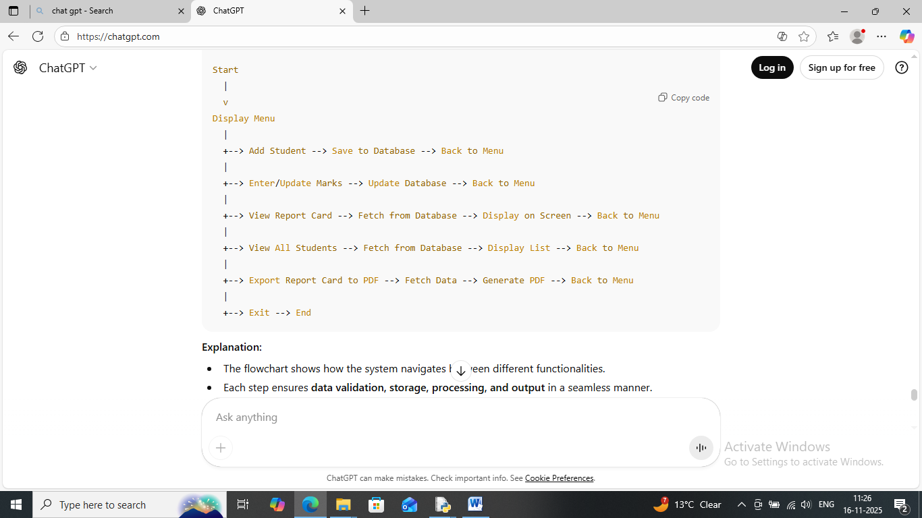
Flowchart

Code Explanation / Implementation
Output Screens / Sample Reports

* Main Menu
- Provides a menu-driven interface:
  - Add Student
  - Enter/Update Marks
  - View Report Card
  - View All Students
  - Export Report Card to PDF
  - Exit
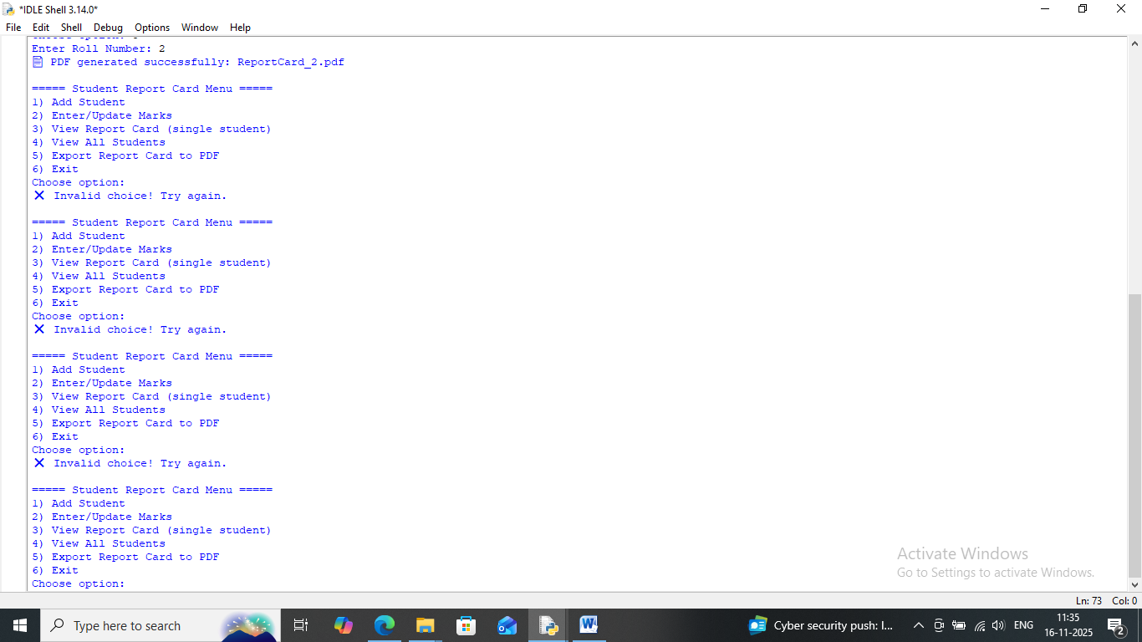
- Loops continuously until the user chooses to exit.

* Database Connection
- SQLite3 is used to create and manage the database reportcard.db.
- A table students stores:
  - Roll Number (Primary Key)
  - Name, Class
  - Marks for Math, Physics, Chemistry, English, Computer

1. Add Student
- Takes Roll Number, Name, Class as input.
- Checks if the roll number already exists to avoid duplicates.
- Inserts student details into the database.
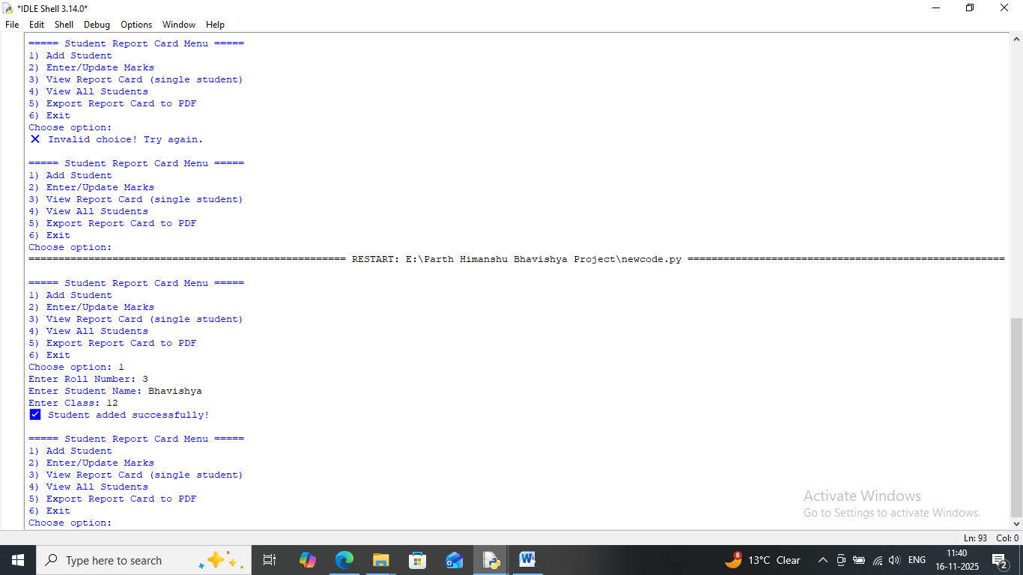

2. Enter/Update Marks
- Prompts user to enter marks for 5 subjects (0–100).
- Validates input for correctness.
- Updates marks in the database for the specified student.
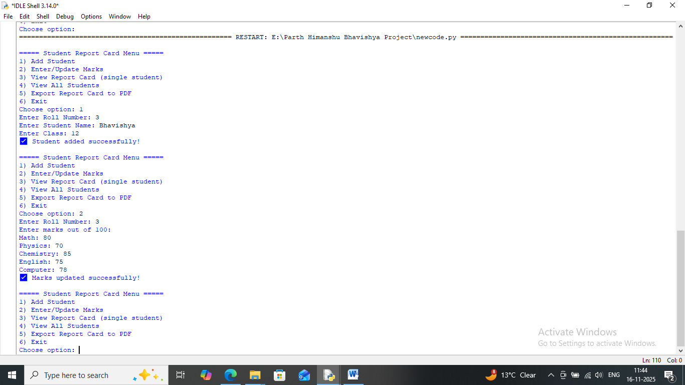

3. View Report Card
- Fetches student data from the database.
- Calculates:
  - Total Marks = sum of all subjects
  - Percentage = total ÷ 5
  - Grade based on percentage
- Displays the report card in a readable format on the screen.
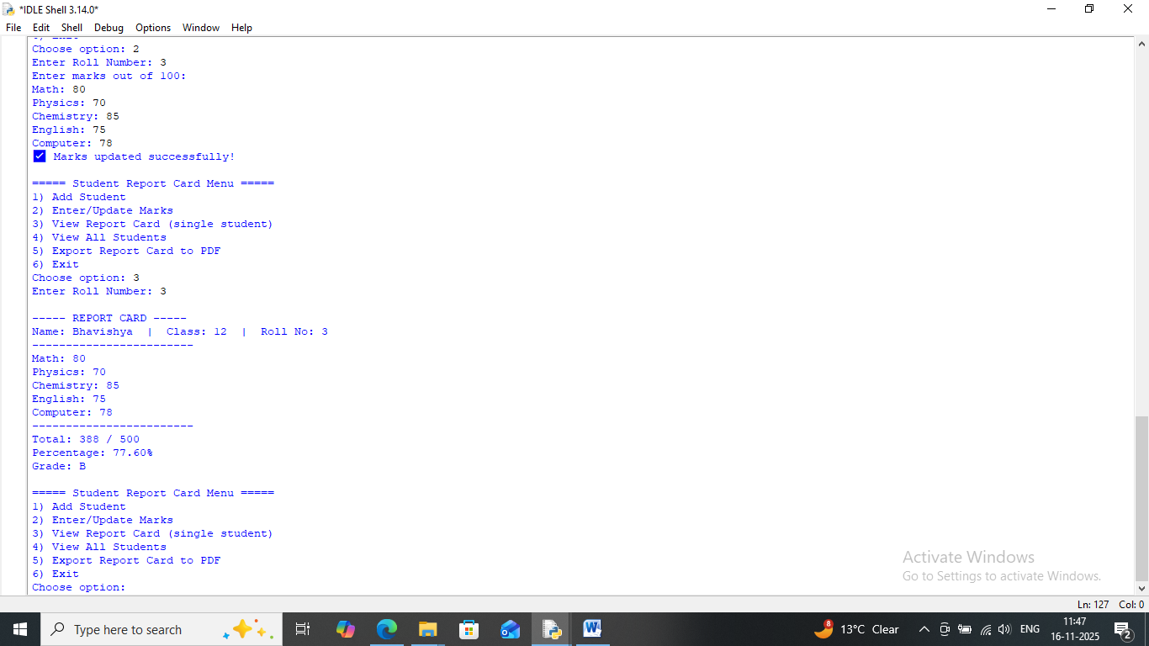

4. View All Students
- Fetches all student records from the database.
- Displays a list of students with Roll Number, Name, and Class.
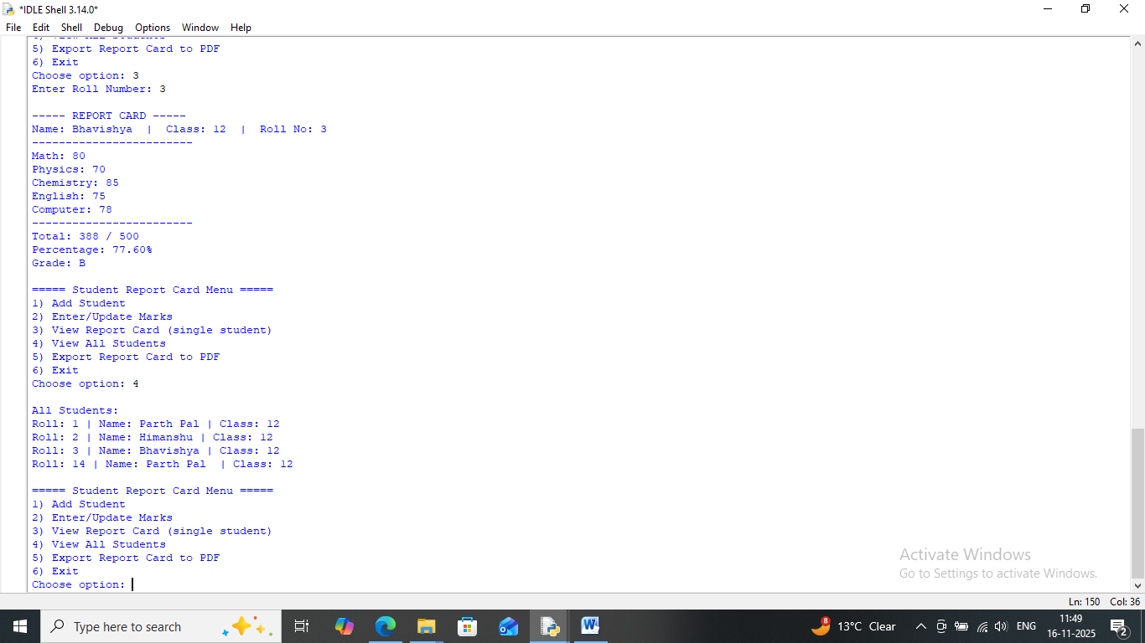

5. Export Report Card to PDF
- Uses ReportLab library to generate professional PDF report cards.
- Features include:
  - School logo and name
  - Student details and marks
  - Total, percentage, and grade
  - Borders and formatted tables
  - Signature boxes for Class Teacher and Principal
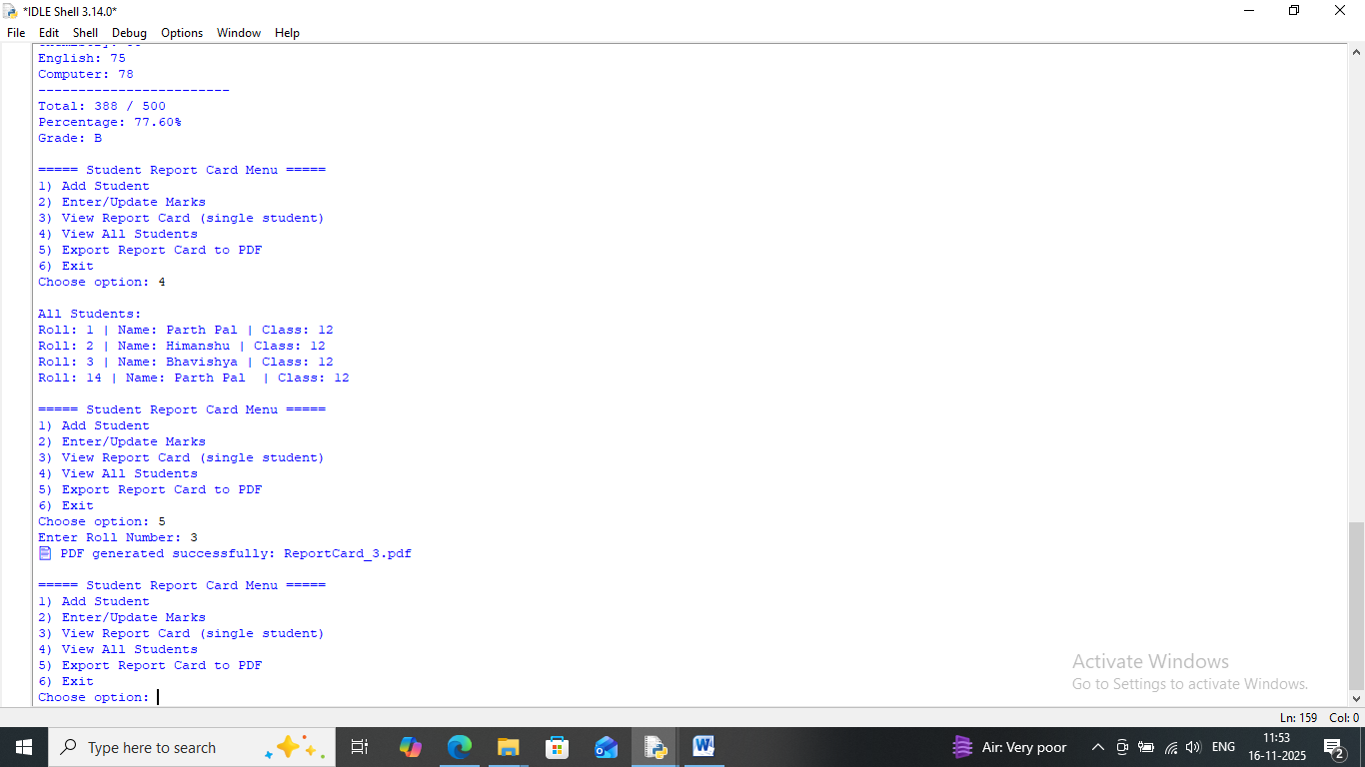

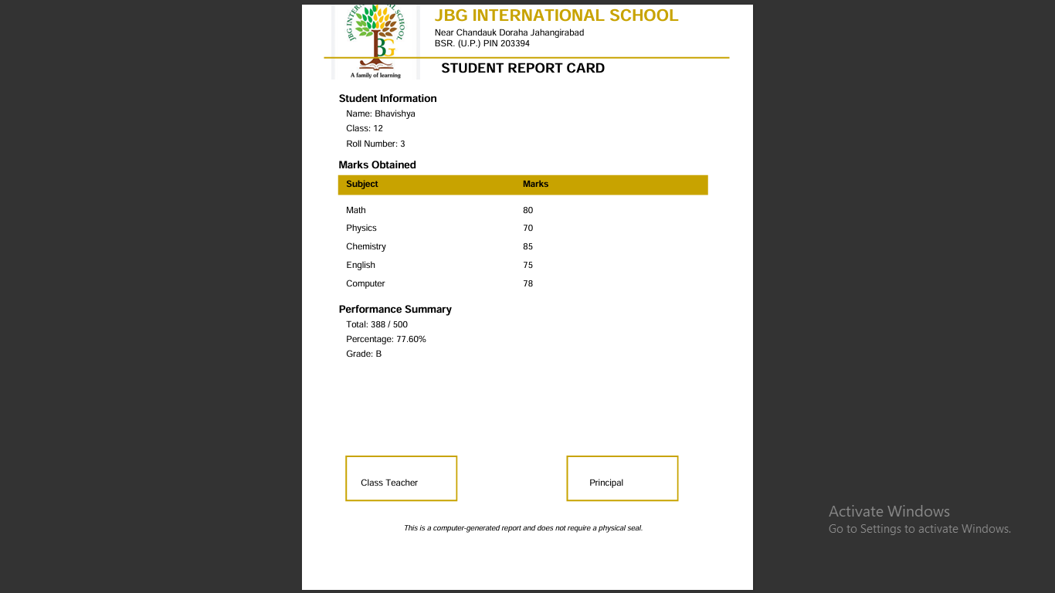

6.Exit
It exits the loop.
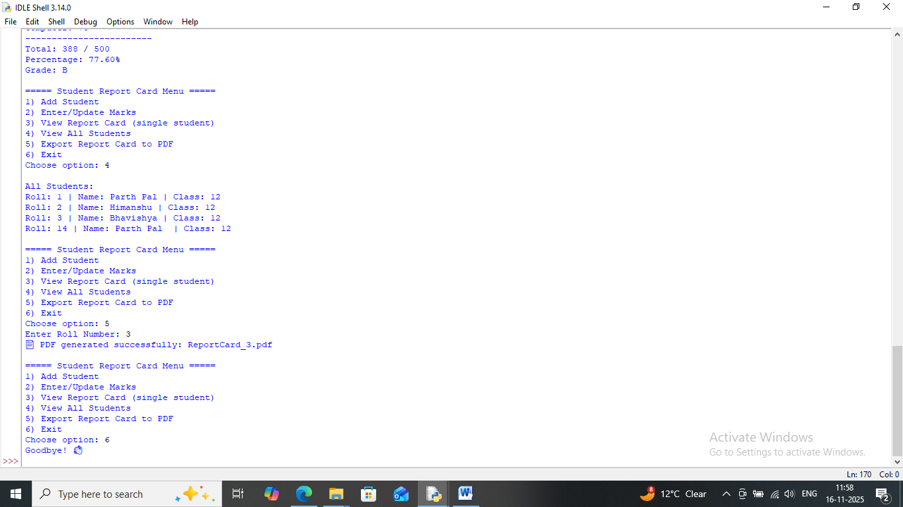

Conclusion and Future Scope

Conclusion
- The Student Report Card Management System successfully automates the process of storing student information, managing marks, and generating report cards.
- It reduces manual effort, ensures accurate calculations, and provides professional PDF output for official use.
- The system is user-friendly, modular, and robust, with proper input validation and database integration.
- Teachers and administrators can easily add students, update marks, view reports, and maintain a digital record of academic performance.

Future Scope
- Web-based or Mobile Application: Convert the system into a web app or mobile app for remote access.
- Advanced Reporting: Include graphs, charts, and progress tracking for better visualization of student performance.
- Multiple Classes & Subjects: Expand the system to handle multiple classes, streams, and additional subjects.
- Automated Grade Analysis: Provide class-wise, subject-wise performance analysis and generate rankings.
- Email/Notification Feature: Automatically send report cards via email to parents or students.
- Cloud Database Integration: Store student data in the cloud for secure and centralized access.

Code
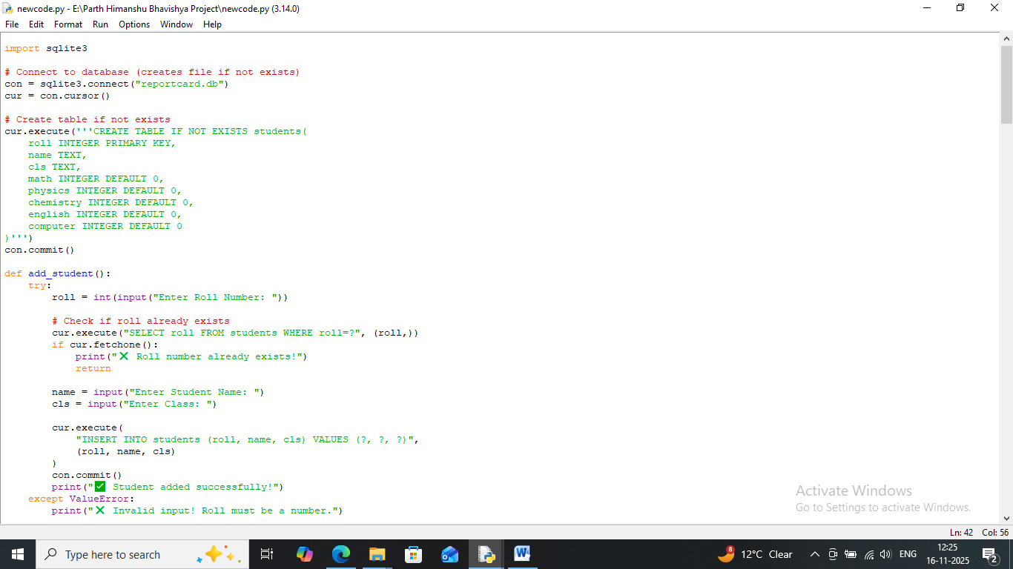

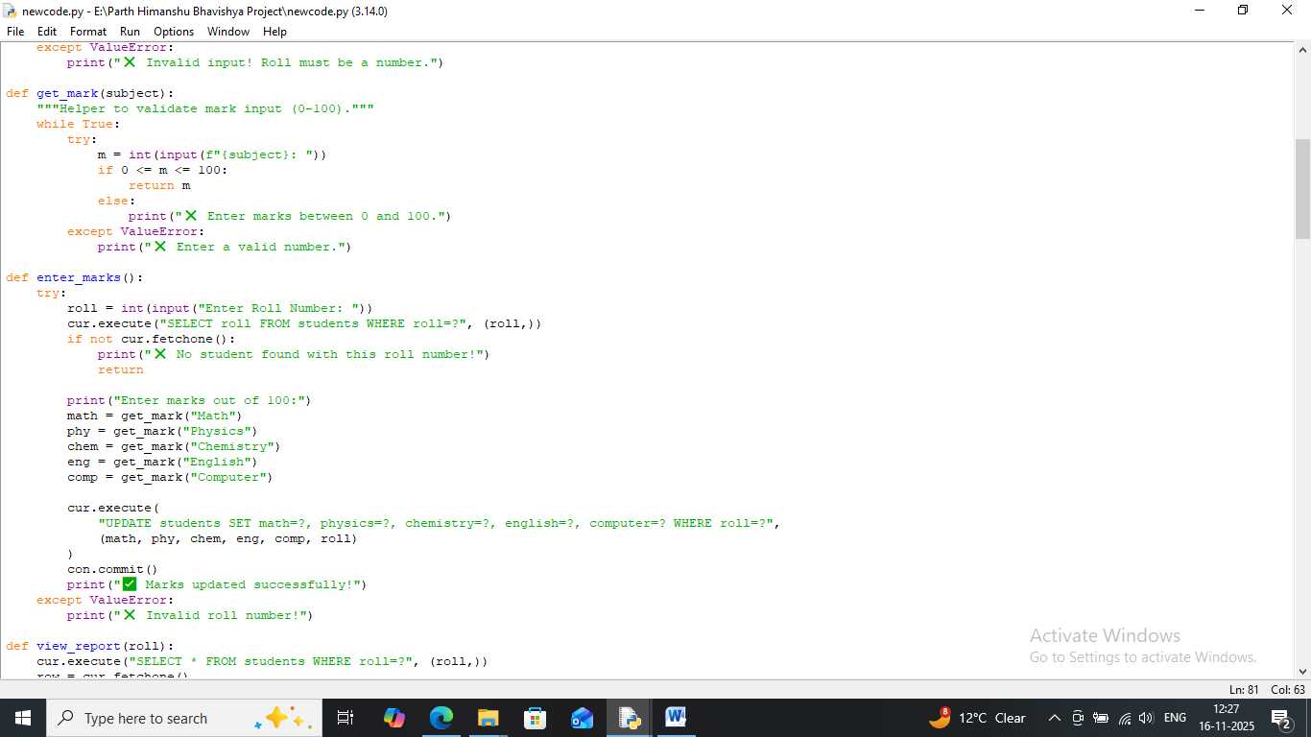

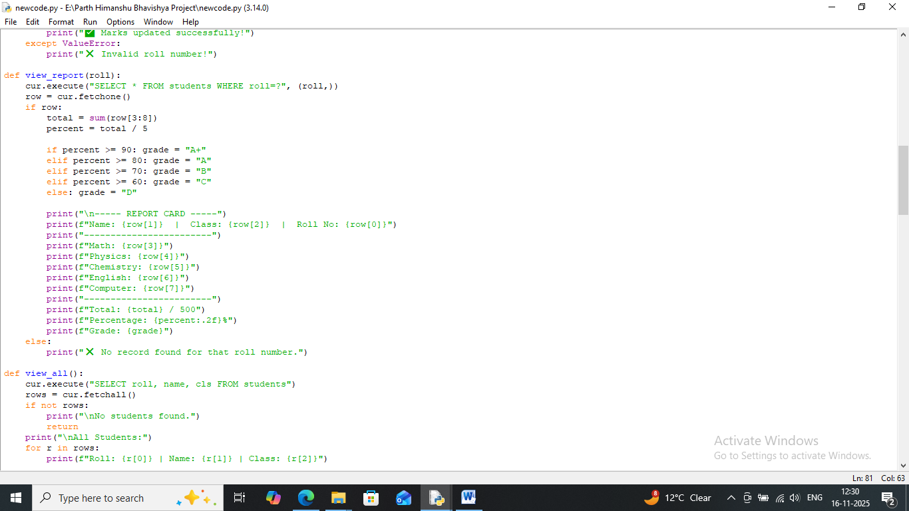

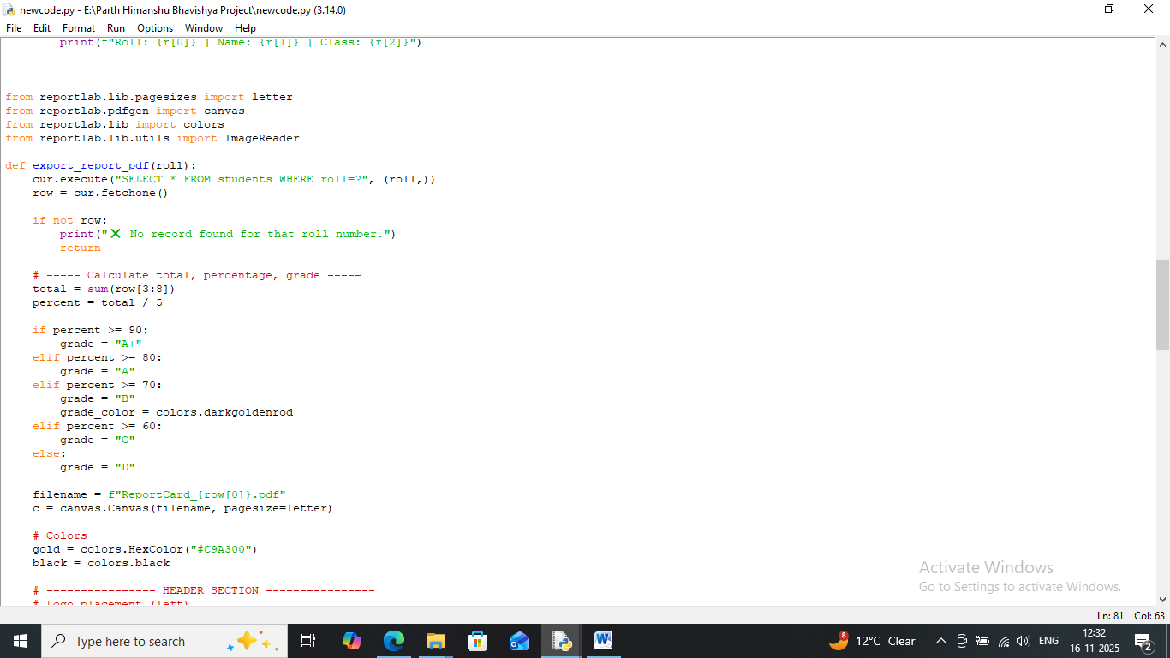

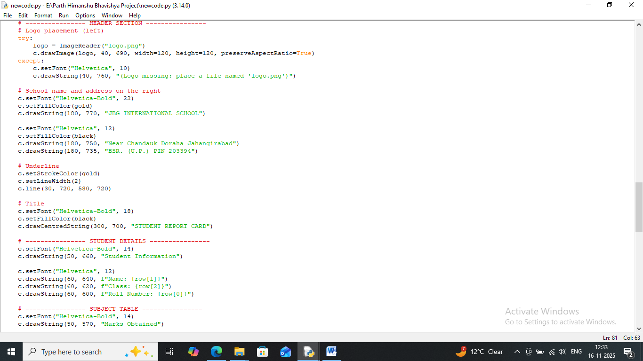

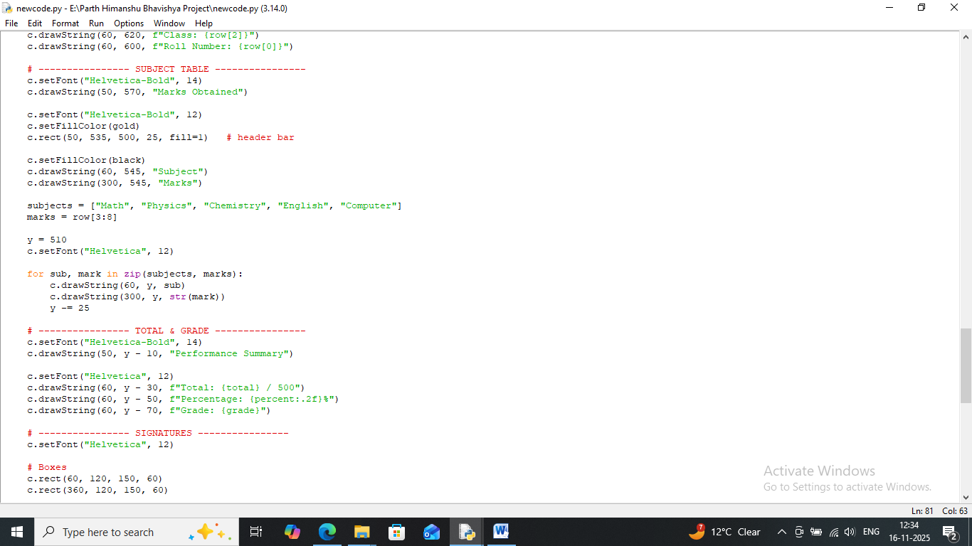

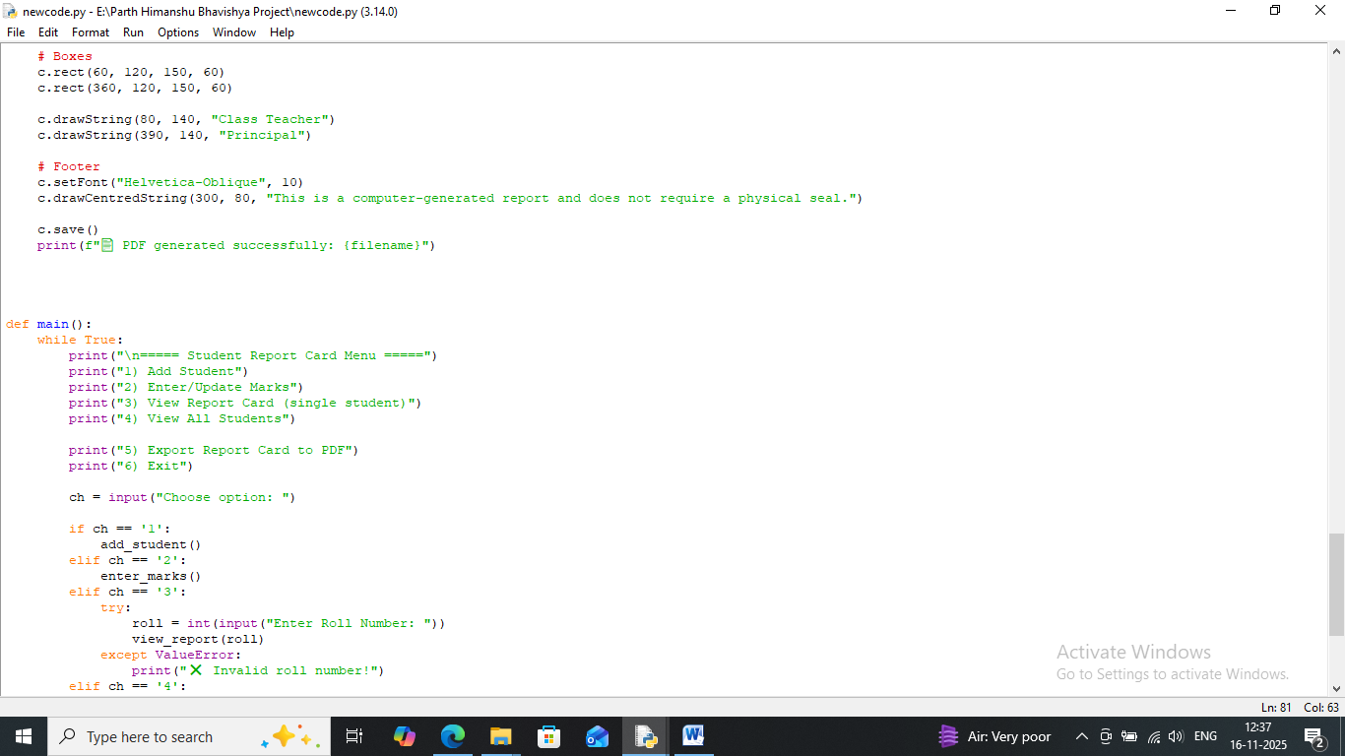

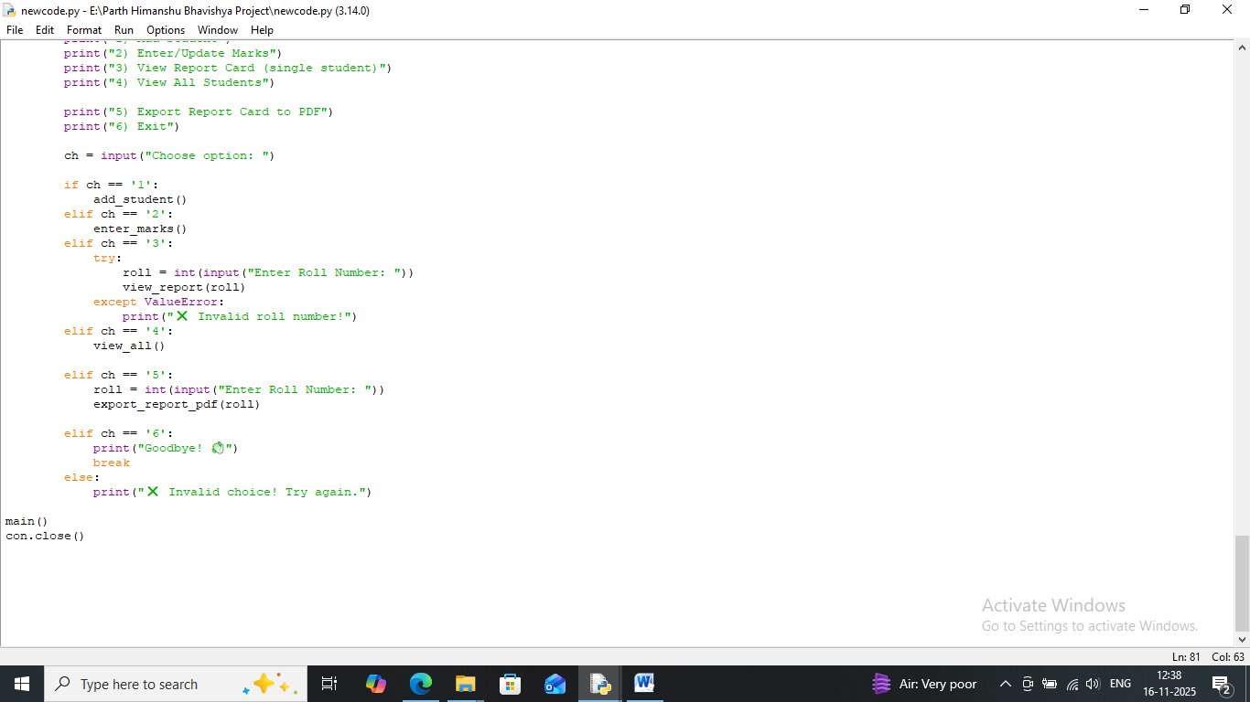

References
- Python Official Documentation
  - Used for Python syntax, functions, and best practices.
- SQLite3 Documentation
  - Used for database creation, queries, and management in Python.
- ReportLab User Guide
  - Used for generating PDF reports with tables, images, and formatted text
- kvcoders.in
- W3School
- GeeksForGeeks
p@|@ktannu3305

